A The drawing refers to one mole of a monatomic ideal gas and shows a process that has four steps, two isobaric (A to B, C to D) and two isochoric (B to C, D to A). Complete the following table by calculating ΔU, W, and Q (including the algebraic signs) for each of the four steps and for the whole process.
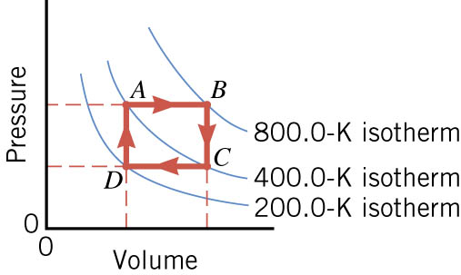

 | ΔU | W | Q
A to B
B to C
C to D
D to A
Total

