Descriptive Statistics and Weighted Averages

By hand or using Excel, find the mean, median, mode, 25th percentile, 75th percentile, maximum, minimum, and range. (Estimate the percentiles when working problems by hand.)

- Professor Ivy has the following scores on her final exams:
97 88 66 55 89 72 94 32 84 89 72 76 77

- Find: Mean ___________(rounded to the nearest hundredth)
Median ______________
Mode ________________
25th percentile _________
75th percentile _________

- Find: Maximum ____________
Minimum _________________
Range ____________________

- The total points scored in the games of an NBA playoff series:

195 176 215 200 189 232 201

- Find: Mean _______________(Round to the nearest whole number)
Median __________________
Mode ____________________

- Find: Maximum _________________
Minimum ______________________
Range _________________________

- a. Determine whether the following distributions are skewed right, skewed left or symmetrical.
b. Write a sentence about the meaning of the skewedness for the information shown on the graphic.
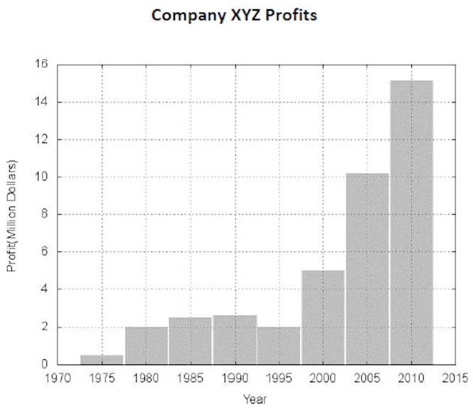
Graphic 1

- a. Determine whether the following distributions are skewed right, skewed left or symmetrical.
b. Write a sentence about the meaning of the skewedness for the information shown on the graphic.
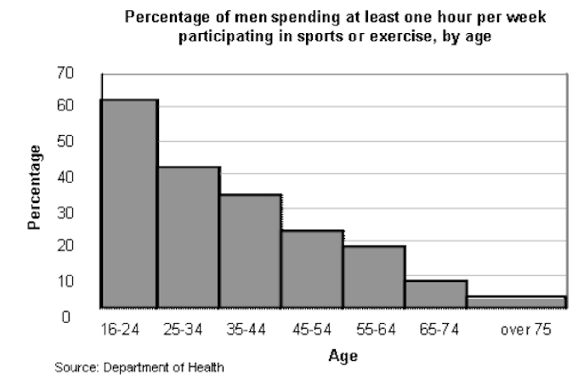
Graphic 2

- a. Determine whether the following distributions are skewed right, skewed left or symmetrical.
b. Write a sentence about the meaning of the skewedness for the information shown on the graphic.
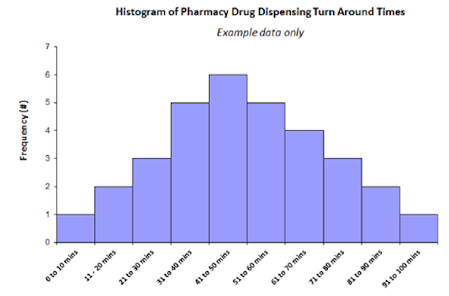
Graphic 3

- Normally, the distribution of birth weights for newborns is symmetrical. Would you expect the distribution of birth weights of babies admitted to neo-natal intensive care units to be symmetrical, skewed left or skewed right? Why?

- Would you expect the distribution of freshman students by age at a four year college (like Indiana University) to be symmetrical, skewed left or skewed right? Why?

- Would the distribution of the heights of high school basketball players to be symmetrical, skewed left or skewed right? Why?

Weighted Averages

- PTK is having a bake sale. They have 30 cookies selling for $0.75 each, 24 cupcakes selling for $1.00 each and 15 brownies selling for $1.50 each. What is the average price of the items sold?

- On the varsity baseball team, there are 9 eighteen-year-olds, 7 seventeen-year-olds, 5 sixteen-year-olds and 2 fifteen-year-olds. What is the average age of the players on the team?

- Calculate the grade point average.
An “A” is considered 4.0, a “B” is 3.0, a “C” is 2.0, a “D” is 1.0, and an “F” is 0. If in your first semester, you received the following grades, what would your grade point average be? (round to the nearest tenth.)

 | Grade Point Hours | Grade
English | 3 | C
Chemistry | 4 | B
Communications | 3 | A
Student Seminar | 1 | A

- Calculate the GPA for the following student.
An “A” is considered 4.0, a “B” is 3.0, a “C” is 2.0, a “D” is 1.0, and an “F” is 0. (Round to the nearest tenth.)

 | Grade Point Hours | Grade
Math | 3 | A
Chemistry | 4 | C
Biology | 3 | B
Computers | 2 | D
PE | 1 | A

- Calculate the final course grade.
A student’s final grade in MATH 123 is determined by the following weights:

 | Weight | Average
Homework | 10% | 80
Quizzes | 10% | 82
Projects | 25% | 78
Exam 1 | 20% | 82
Exam 2 | 20% | 84
Exam 3 | 15% | 65

- What is the final course grade for this MATH 123 student? (Round to the nearest tenth.)

- What letter grade would this student earn based on the grading scale for MATH 123? (Hint: Grading scale is listed in the syllabus and course overview.)

- What is the highest course grade he could earn if he improved his homework grade? (Rounded to the nearest tenth.) Which would result in what letter grade with no rounding up?

- Calculate the final grade.
A student’s final grade in chemistry is determined by the following weights:

Lab report 15%
Quizzes 5%
Exam 1 20%
Exam 2 20%
Research Paper 15%
Final exam 25%

Use the following grades for a particular student:

Lab report | 75 | 80 | 70 | 75 | 85 | 69 | 90 | 75
Quizzes | 85 | 60 | 70 | 0 | 75 | 80 | 80 | 80
Exam 1 | 80
Exam 2 | 70
Research paper | 85
Final exam | 75

- What is the average lab report grade for this student? (Rounded to the nearest tenth).

- What is the average quiz score? (Rounded to the nearest tenth).

c. What is the final grade for this student? (Rounded to the nearest tenth).

- The Excel spreadsheet provided shows the number of Teens aged 16-19 not attending school and not working in 2013. Source http://datacenter.kidscount.org/data/tables/

- Download Excel spreadsheet with data. Use the Excel formulas and functions to find the Mean, Median, Mode, Maximum, Minimum, Range for the number of 16-19 year olds not attending/working in 2013.

- Use the same Excel spreadsheet from 15a. Use the Excel formulas and functions to find the Mean, Median, Mode, Maximum, Minimum, Range for the percent of 16-19 year olds not attending/working in 2013.
- Write a paragraph about your findings regarding teens not attending school and not working. When comparing the states is it better to compare the number or the percent? Why? How does the state of Indiana compare to the surrounding states?

