Descriptive Statistics Exercise
Descriptive Statistics
- Answer the following questions using the table and data below:
- What is the mean age of this sample? What is the standard deviation?
- Create a frequency distribution table for denomination.

Denomination
 |  | Frequency | Percent | Valid Percent | Cumulative Percent
Valid | Episcopal | 1 | 5.0 | 5.0 | 5.0
 | Lutheran | 2 | 10.0 | 10.0 | 15.0
 | Presbyterian | 2 | 10.0 | 10.0 | 25.0
 | Other Mainline Protestant | 1 | 5.0 | 5.0 | 30.0
 | Baptist | 3 | 15.0 | 15.0 | 45.0
 | Other Evangelical Protestant | 3 | 15.0 | 15.0 | 60.0
 | Pentecostal | 1 | 5.0 | 5.0 | 65.0
 | Charismatic | 3 | 15.0 | 15.0 | 80.0
 | Non-Denominational | 3 | 15.0 | 15.0 | 95.0
 | Other | 1 | 5.0 | 5.0 | 100.0
 | Total | 20 | 100.0 | 100.0
- What is the percentage of people who identify themselves as Baptist in this sample?
- What is the mode of church attendance?
The mode of church attendance is 5, twice a week.
The table below presents data for a sample of people who completed a religious survey.
Age | Gender | Denomination | Church Attendance
56 | 1 | 7 | 4
46 | 2 | 6 | 5
49 | 2 | 6 | 5
49 | 1 | 1 | 5
27 | 2 | 9 | 5
51 | 1 | 4 | 2
47 | 2 | 2 | 3
67 | 1 | 5 | 4
49 | 2 | 2 | 6
33 | 1 | 12 | 6
55 | 2 | 9 | 5
40 | 1 | 7 | 5
62 | 1 | 8 | 6
47 | 2 | 6 | 3
56 | 2 | 9 | 5
22 | 1 | 10 | 2
50 | 2 | 4 | 5
51 | 1 | 10 | 6
50 | 1 | 7 | 6
43 | 1 | 10 | 3
In this table, the numbers in the gender, denomination, and church attendance columns represent the following:
Gender
- Male
- Female
Denomination
- Episcopal
- Lutheran
- Methodist
- Presbyterian
- Other Mainline Protestant
- Baptist
- Other Evangelical Protestant
- Pentecostal
- Charismatic
- Non-Denominational
- Catholic
- Other
Church Attendance
- Less than once a month
- Once a month
- A few times a month
- Once a week
- Twice a week
- Three or more times a week
- The results of a recent survey indicate that the average new car costs $23,000, with a standard deviation of $3,500. The price of cars is normally distributed.
- What is a Z score for a car with a price of $33,000?

- What is a Z score for a car with a price of $30,000?

- At what percentile rank is a car that sold for $30,000?

- In one elementary school, 200 students are tested on the subjects of math and English. The table below shows the mean and standard deviation for each subject.
Subject | Mean | SD
Math | 67 | 9.58
English | 78 | 12.45
One student’s math score was 70 and the same student’s English score was 84. On which exam did the student do better?

- Suppose you administered an anxiety test to a large sample of people and obtained normally distributed scores with a mean of 45 and a standard deviation of 4. Do not use the web calculator to answer the following questions. Instead, use the Z distribution table below and Appendix A in the Jackson text.
- If Andrew scored 45 on this test, what is his Z score?

- If Anna scored 30 on this test, what is her Z score?

- If Bill’s Z score was 1.5, what is his real score on this test?

- There are 200 students in a sample. How many of these students will have scores that fall under the score of 41?

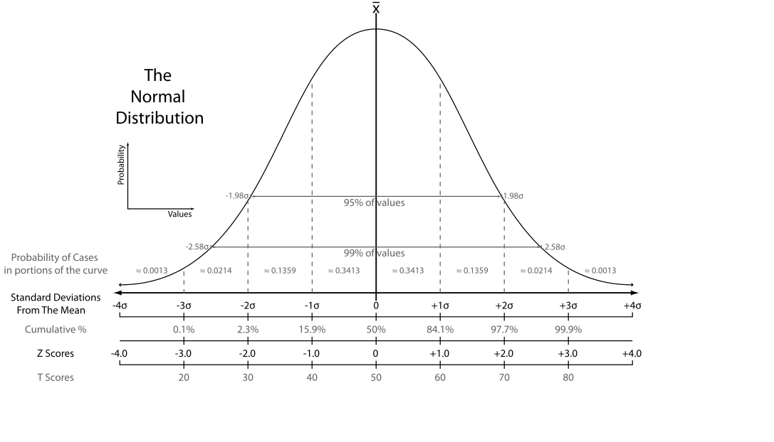
Caption: The Normal Distribution Curve.
“The Normal Distribution”, ©2007, used under a creative commons attribution- Share alike 3.0 unported license with address: http://commons.wikimedia.org/wiki/File:The_Normal_Distribution.svg. Retrieved from: http://commons.wikimedia.org/wiki/File:The_Normal_Distribution.svg.

