The Leisure Life of China’s Elites (pp. 356-361),
From the earliest centuries of Chinese civilization, that country’s artists have painted — on pottery, paper, wood, and silk; in tombs, on coﬃns, and on walls; in albums and on scrolls. Relying largely on ink rather than oils, their brushes depicted human ﬁgures, landscapes, religious themes, and images of ordinary life. While Chinese painting evolved over many centuries, in terms of both subject matter and technique, by most accounts it reached a high point of artistic brilliance during the Tang and Song dynasties.
Here, however, we are less interested in the aesthetic achievements of Chinese painting than in what those works can show us about the life of China’s elite class — those men who had passed the highest-level examinations and held high oﬃce in the state bureaucracy and those women who lived within the circles of the imperial court. While they represented only a tiny fraction of China’s huge population, such elite groups established the tone and set the standards of behavior for Chinese civilization. For such people, leisure was a positive value, a time for nurturing relationships and cultivating one’s character in good Confucian or Daoist fashion. According to the Tang dynasty writer and scholar Duan Chengshi,
Leisure is good.
Dusty aﬀairs don’t entangle the mind.
I sit facing the tree outside the window
And watch its shadow change direction three times.
Action and work, in the Chinese view of things, need to be balanced by self-reﬂection and leisure. In the images that follow, we can catch a glimpse of how the Chinese elite lived and interacted with one another, particularly in their leisure time. Leading court oﬃcials and scholar-bureaucrats must have been greatly honored to be invited to an elegant banquet, hosted by the emperor himself, such as that shown in Source 8.1. Usually attributed to the emperor Huizong (1082–1135) — who was himself a noted painter, poet, calligrapher, and collector — the painting shows a reﬁned dinner gathering of high oﬃcials drinking tea and wine with the emperor presiding at the left. This emperor’s great attention to the arts rather than to aﬀairs of state gained him a reputation as a negligent and dissolute ruler. His reign ended in disgrace as China suﬀered a humiliating defeat at the hands of northern nomadic Jin people, who took the emperor captive.
Pg 357
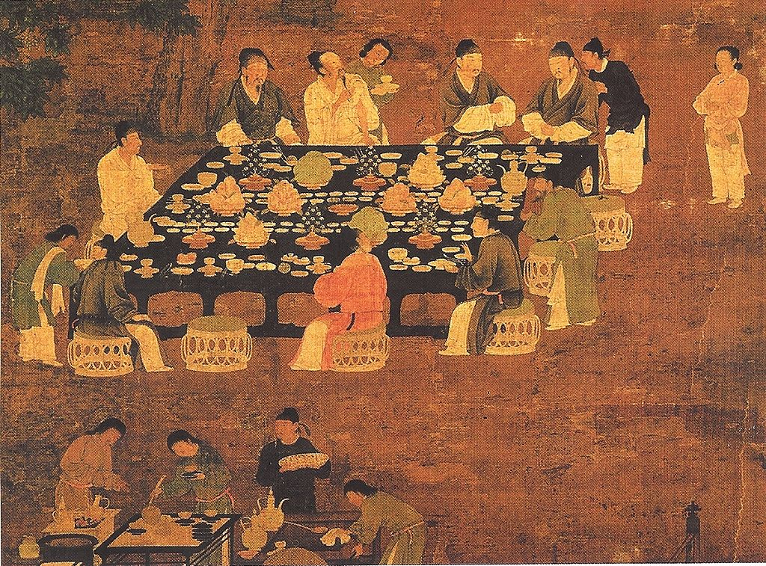
What features of this painting contribute to the impression of imperial elegance?
What mood does this painting evoke?
What social distinction among the ﬁgures in the painting can you discern?
How is the emperor depicted in this painting in comparison to that on page 335? How would you explain the diﬀerence?
How might you imagine the conversation around this table?
Elite women of the court likewise gathered to eat, drink, and talk, as illustrated in Source 8.2, an anonymous Tang dynasty painting on silk. Hosting the event is the empress, shown seated upright in the middle of the left side of the table, holding a fan and wearing a distinctive headdress. Her guests and paid professional musicians sit around the table.
How does this gathering of elite women diﬀer from that of the men in Source 8.1? How might their conversation diﬀer from that of the men?
To what extent are the emperor and empress in Sources 8.1 and 8.2 distinguished from their guests?

Pg, 358
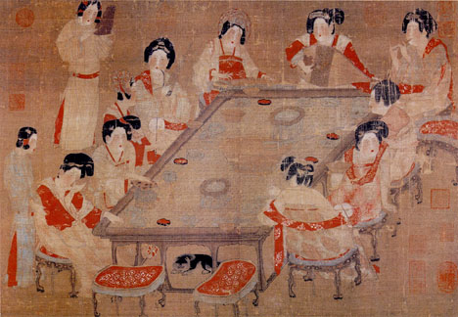

How do you think the emperor and empress viewed their roles at these functions? Were they acting as private persons among friends or in an oﬃcial capacity?
What diﬀerences in status among these women can you identify?
What view of these women does the artist seek to convey?
What does the posture of the women suggest about the event?
Confucian cultural ideals gave great prominence to literature, poetry, and scholarly pursuits as leisure activities appropriate for “ gentlemen.” Confucius himself had declared that “ gentlemen make friends through literature, and through friendship increase their benevolence.” For some, a more reclusive life devoted to study, painting, poetry, and conversation with friends represented an honorable alternative to government service. Thus literary gatherings of scholars and oﬃcials, often in garden settings, were common themes in Tang and Song Dynasty paintings. Source 8.3, by the tenth-century painter Zhou Wenju, provides an illustration of such a gathering.

Pg 359
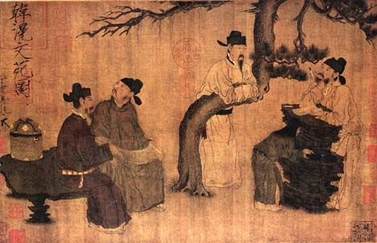
What marks these ﬁgures as cultivated men of literary or scholarly inclination?
What meaning might you attribute to the outdoor garden setting of this image and that of Source 8.1?
Notice the various gazes of the four ﬁgures. What do they suggest about the character of this gathering and the interpersonal relationships among its participants? Are they interacting or engaged in solitary pursuits?
Do you think the artist was seeking to convey an idealized image of what a gathering of “ gentlemen” ought to be or a realistic portrayal of an actual event? What elements of the painting support your answer?
Not all was poetry and contemplation of nature in the leisure-time activities of China’s elite. Nor were men and women always so strictly segregated as the preceding sources may suggest. Source 8.4 illustrates another side of Chinese elite life. These images are part of a long tenth-century scroll painting
Pg360
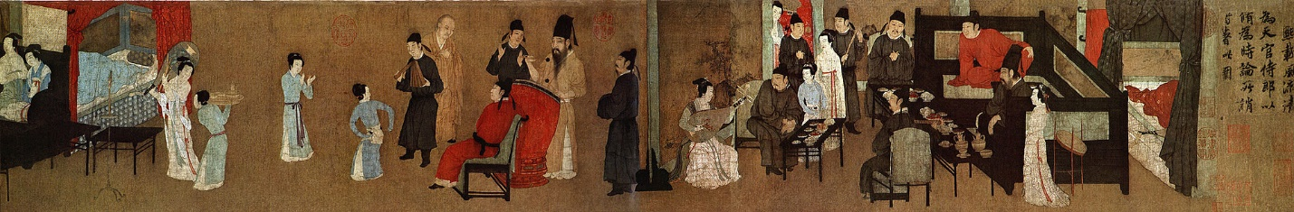
Titled, The Night Revels of Han Xizai. Apparently, the Tang dynasty emperor Li Yu became concerned that one of his ministers, Han Xizai, was overindulging in suspicious night long parties in his home. He, therefore, commissioned the artist Gu Hongzhong to attend these parties secretly and to record the events in a painting, which he hoped would shame his wayward but talented oﬃcial into more appropriate and digniﬁed behavior. The entire scroll shows men and women together, sometimes in ﬂirtatious situations, while open sleeping areas suggest sexual activity.
What kinds of entertainment were featured at this gathering?
What aspects of these parties shown in the scroll paintings might have caused the emperor some concern? Refer back to the female musicians shown on page 211, which derives from the same painting. In what respects might these kinds of gatherings run counter to Confucian values?
How are women portrayed in these images? In what ways are they relating to the men in the painting?
Pg361
DOING HISTORY The Leisure Life of China’s Elites
1. Describing elite society: Based on these paintings, write a brief description of the social life of Chinese elites during the Tang and Song dynasties.
2. Deﬁning the self-image of an elite: What do these sources suggest about how members of the elite ideally viewed themselves? In what ways do those self-portraits draw upon Confucian, Daoist, or Buddhist teachings?
3. Noticing diﬀerences in the depiction of women: In what diﬀerent ways are women represented in these paintings? Keep in mind that all the artists were men. How might this aﬀect the way women were depicted? How might female artists have portrayed them diﬀerently?
4. Using images to illustrate change: Reread the sections on Chinese women (pages 211–13 and 331–32). How might these images be used to illustrate the changes in women’s lives that are described in those pages?
5. Seeking additional sources: What other kinds of visual sources might provide further insight into the lives of Chinese elites

Pg 211-213
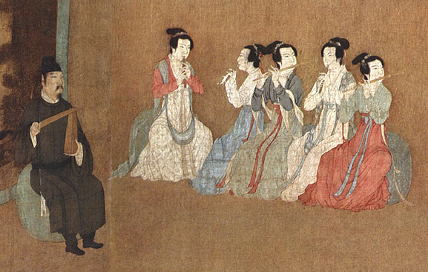

Pg212
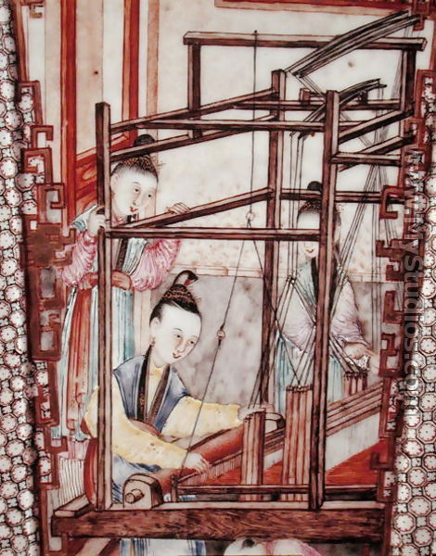

Pg 332
