Question 1
Spend some in the library or on internet to study the nuclear chart and then write a short article (between half a page and one page) where you explain what it is and why it is interesting (you can choose to focus on a portion of the chart of nuclides). Plan it as if the article had to appear on a outreach magazine, like Scientific American or New Scientist.
My references are:
Ref: http://www.karlsruhenuclidechart.net,
http://www.nucleonica.com
https://en.wikipedia.org/wiki/Table_of_nuclides
The nuclear chart was first published by Giorgio Fea in 1935, and expanded by Emilio Segrè in 1945 or G. Seaborg. In 1958, Walter Seelmann-Eggebert and Gerda Pfennig published the first edition of the Karlsruhe Nuclide Chart.. Today, one finds several nuclide charts, four of them have a wide distribution: the Karlsruhe Nuclide Chart, the Strasbourg Universal Nuclide Chart, the Chart of the Nuclides from the JAEA and the Nuclide Chart from Knolls Atomic Power Laboratory. Since its first edition in 1958, the Karlsruhe Nuclide Chart has provided scientists and students with structured and accurate information on the half-lives and decay modes of radionuclides, as well as the energies of emitted radiation. Beyond the more traditional physical sciences such as health physics and radiation protection, nuclear radiochemistry and astrophysics, the chart is now in common use in life and earth sciences such as biology, medicine, agriculture and geology. The Karlsruhe Nuclide Chart shows all known nuclides in a clear two dimensional co-ordinate system of nuclide boxes depicting the number of protons and neutrons in the atomic nucleus. A nuclide box of the chart contains the element symbol, the mass number and other nuclear data on the nuclide characterised by the position in the neutron-proton co-ordinate system. The colours of the nuclide boxes represent the different radioactive decay modes of the radionuclides. The term "nuclide" categorises atoms by the number of protons and neutrons in its nucleus. Nuclide charts offer a full description of the radioactive attributes of an element and its known isotopes, providing a unique overview of the current knowledge in nuclear science

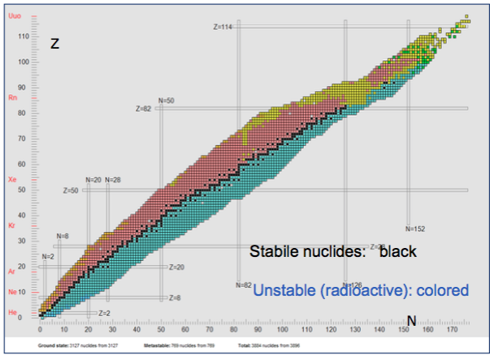

neutrons in atomic nucleus. Stable nuclide fall in a narrow range of neutron to proton ration. The stability of nuclei is significant for special (magic) number of protons and neutrons.
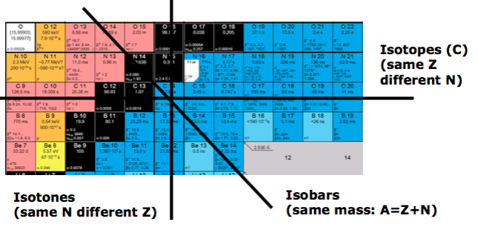
The chart contains information on the basic properties of known nuclides. Each nuclide is represented by a box containing basic nuclear data. The data consists of the half life, neutron cross section, main gamma lines, etc. An important characteristic of the chart is the use of colors to denote the mode of decay, half- life, or cross-sections. If the nuclide has one or more meat stable states, the box is subdivided into smaller boxes for each state.

