Hello, Please I want to answer these problems. Please help me thinks.

Problem 1) Look at the scatter plot below. Does it demonstrate a positive or negative correlation? Why?
Are there any outliers? What are they?

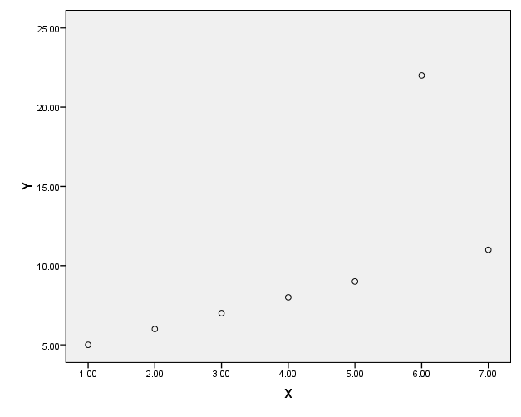

Problem 2) Look at the scatter plot below. Does it demonstrate a positive or negative correlation? Why?
Are there any outliers? What are they?

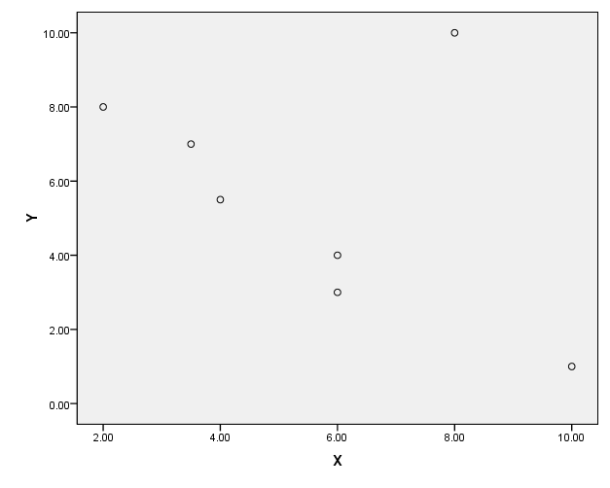

Problem 3) The following data come from your book, problem 26 on page 247. Here is the data:

Mean daily calories Infant Mortality Rate (per 1,000 births)
1523 154
3495 6
1941 114
2678 24
1610 107
3443 6
1640 153
3362 7
3429 44
- 7

  - For the above data construct a scatter plot using SPSS or Excel (Follow instructions on page 244 of your textbook). What does the scatter plot show? Can you determine a type of relationship? Are there any outliers that you can see?
  - Using the same data conduct a correlation analysis using SPSS or Excel. What is the correlation coefficient? Is it a strong, moderate or weak correlation? Is the correlation significant or not? If it is what does that mean?

Problem 4)

Bill is doing a project for you in the marketing department. In conducting his analysis regarding consumer behavior and a new product that has come out, he tells you the correlation between these two variables is 1.09. What is your response to this analysis?

Problem 5)

Judy has conducted an analysis for her supervisor. The results she obtained was a correlation coefficient that was negative 0.86. Judy is confused by this number and feels that because it is negative and not positive, is means that it is bad. You are here supervisor. How would you clarify this result for Judy regarding the meaning of the correlation?

Problem 6)

Explain the statement, “correlation does not imply causality.”
Problem 7)

Using the best-fit line below for prediction, answer the following questions:

- What would you predict the price of Product X in volume of 150 to be (approximately)?
- What would you predict the price of Product X in volume of 100 to be (approximately)?

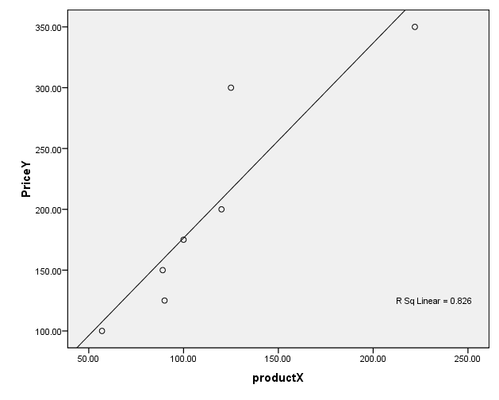
Problem 8)

You are interested in finding out if a student’s ACT score is a good predictor of their final college grade point average (GPA). You have obtained the following data and are going to conduct a regression analysis. Follow instructions on page 244 of your textbook under line of best fit to conduct this analysis?
ACT GPA
22.0 3.0
32.0 3.78
33.0 3.68
21.0 2.94
27.0 3.38
25.0 3.21
30.0 3.65

- What is the R? What type of relationship does it indicate (strong/weak; positive/negative)?
- Go to the coefficients readout. The constant is the intercept. Under that is the ACT and that is the slope. Using the straight line formula of Y = mx + b, which you will find on page 262, you will now predict some future GPA scores: In the formula (m) is the slope; (x) is the variable that you are looking to use as a predictor; and (b) is the intercept. Predict GPA from the following ACT scores using the regression equation/straight line formula (show all your work):

  - 20
  - 25
  - 34

