Shirley Williams
04-15-2016
MTH 112
Week 3 Seminar Application Activity: Angry Birds

Seminar 3 Application Activity: Angry Birds
Consider the following scenario:
Red Bird, Yellow Bird, Blue Bird and Black Bird are angry with the pigs who stole the birds’ eggs. The birds want their eggs back and will stop at nothing to get them back. The flight path of the birds can be modeled with a parabola where “x” is the distance and “y” is the height.
Use the data below to help answer the following questions:
- Red Bird starts his flight from point (10, 0). His flight path reaches a maximum height of 18 yards and lands at point (38, 0).
- Yellow Bird’s flight path can be modeled by the quadratic equation $y={-x}^{2}+14x-24$
- Blue Bird’s flight is modeled by the following graph:
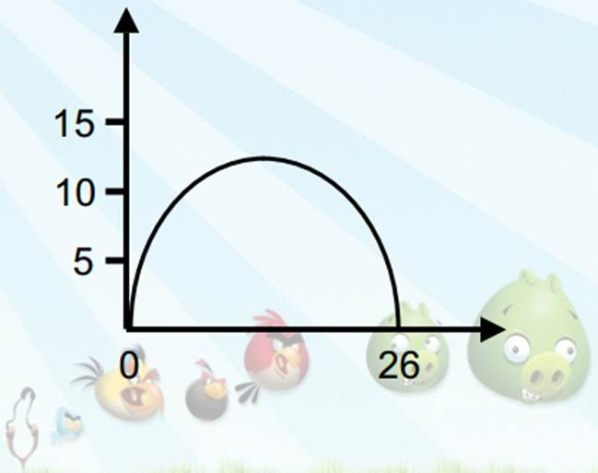
- The table below contains partial data points of Black Bird’s trajectory:
x | 8 | 9 | 10 | 11 | 12 | 13 | 14 | 15 | 16 | 17 | 18
y | 0 | 7.5 | 14 | 19.5 | 24 | 27.5 | 30 | 31.5 | 32 | 31.5

In developing responses to the problems, be sure to show all work:
- What is the maximum height of each bird’s flight: (4points)
- What is the axis of symmetry for each bird’s flight: (4 points)
- What was the total horizontal distance of each bird’s flight: (4 points)
- Which bird flew the highest? (2 points)
- Which bird traveled the greatest horizontal distance? (2 points)
- Which bird hit the following pigs:
  - King Pig located at point (21, 19.5) (2 points)
  - Moustache Pig located at point (9, 21) (2 points)

