Transportation
Petroleum-derived liquid fuels are the overwhelming source of energy in the current transportation infrastructure. The geographical distribution of petroleum resources is changing as reserves are found and accessed with improved technologies for discovery and production. However, this distribution of oil supply generally does not coincide with where the demand is located. For example, many countries import oil at an unprecedented scale, which can lead to significant balance-of-trade and national-security challenges. In 2011, about 2.690 billion tonnes of oil were consumed; of this, 1.895 billion tonnes of crude oil and 0.791 billion tonnes of refined products crossed national borders⁵ and significant discoveries of oil, natural-gas liquids and natural gas could potentially alter the global-energy landscape⁶.
We will review some of the opportunities and challenges related to transportation technologies. For example, most of the future infrastructure of the world will be built in locations where we have the greatest opportunity to transition to sustainable mobility. Desirable and affordable public transportation that is fully integrated into urban planning⁷, and the use of information technologies to assist and displace transportation can significantly reduce fuel consumption, but are not discussed in this Perspective.
The Quadrennial Technology Review (QTR) of the US DOE provides a broad overview of state-of-the-art technologies and opportunities for future research⁸. Improvements in energy efficiency of vehicles can greatly reduce oil dependency. These improvements include increased use of light-weight materials, such as advanced ultra-high tensile strength steels, aluminium and magnesium alloys, polymers, and carbon-fibre reinforced composite materials⁹. The integration of lighter weight materials is especially important if more complex parts can be manufactured as a single unit. The potential for reducing the weight of vehicles has already been shown, and in the next 10–20 years, an additional 20–40% reduction in overall weight, without sacrificing safety, seems to be possible¹⁰. For every 10% weight reduction of the vehicle, an improvement in fuel consumption of 6–8% is expected¹¹.
Reducing energy losses as a result of friction is also possible¹² (Fig. 2). Advances in cost-effective technologies such as tribology, tyres, braking and waste-heat energy recovery, and aerodynamics could potentially lead to efficiency improvements of 20% in the short term and more than 60% over a longer term (15–25 years).
Figure 2: Vehicle energy losses.
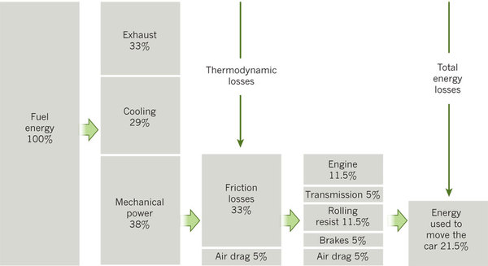
Of the energy that fuel provides to vehicles a substantial proportion is lost. A breakdown of the average losses of internal-combustion-engine cars (fleet make up 70% petrol and 30% diesel) is shown. Heat lost constitutes 30–37% of the energy as a result of exhaust gases with lower energy content and convection. The other losses come from heat dissipation (25–33%), mechanical losses (33–40%), air drag (3–12%), rolling friction (12–45%) and brake losses (about 5%). These losses mean only about 21.5% of the energy is used to move the car.

Internal combustion engines
The internal combustion engine using liquid-transportation fuel (or liquid ICE) will probably continue to have a major role over the next few decades. However, improvements to the efficiency of the liquid ICE are possible because the efficiency of most spark-ignition engines is typically 25–35%, whereas that for compression-ignition diesel engines is about 40–50%. With direct injection, lean burn and turbocharger technologies, the spark-ignition ICEs operating on premium octane ratings can approach diesel efficiencies. The combination of in situ measurements of prototype ICE designs with detailed simulations, which are made possible with high-performance computers, are increasing the energy efficiency and have lowered emissions^{13, 14}. Finally, low-cost waste-heat recovery can increase efficiency, especially in heavy-duty vehicles. Approaches include use of the Rankine cycle to convert waste heat to work, and the development of low-cost and high-efficiency solid-state thermoelectric systems¹⁵.

Battery-based electrification
Plug-in hybrid and all-electric light- and medium-duty vehicles have the opportunity to displace a significant amount of liquid fuel use in transportation. The main challenges are performance and cost of the battery systems. The performance of battery systems is quantified by usable energy density, power density (including fast charging), cycle lifetime and robustness. In the past 5–6 years, a remarkable amount of progress in research has been made in battery cathodes, anodes and electrolytes. Large volumetric changes in the electrodes have led to designs in which micro- or nanostructures are embedded in a conducting and flexible matrix to allow for the relief of mechanical stresses. State-of-the-art batteries based on graphite anodes and lithium-manganese-oxide composite cathodes for lithium batteries are being commercialized¹⁶. Within the next few years, battery system packs of 200 Watt-hour kg⁻¹ at a charging rate of full charge in 3 hours, which is double the current cell-energy density, are expected to become available. The current production cost of a vehicle battery is estimated to be US$650 kWh⁻¹ of usable energy storage, but this is expected to drop to below $150 kWh⁻¹ by 2030 (ref. 17).
The US DOE is supporting a research and development effort that would allow a four or five passenger plug-in hybrid electric vehicle (PHEV) or an electric vehicle with about a 160-km range to be competitive as a mass-market ICE car within a decade. The US DOE EV-Everywhere challenge for PHEV, will require the cost of the battery system to be reduced by an estimated $190–300 kWh⁻¹, depending on whether the car is a PHEV or an electric vehicle. The development of anode-protecting materials and non-flammable electrolytes that are stable at high voltage and tolerate 55 °C are desired characteristics of third-generation lithium-ion batteries. Developing batteries beyond lithium-ion batteries, such as lithium-sulphur and metal-air batteries, could achieve up to ten times the energy density of the current lithium-ion batteries, but materials research is needed to develop anode and cathode protection, as well as non-flammable electrolytes with electrochemical stability over a large potential range.
Battery packs typically use about 50% of the total battery capacity, and the charging rates are limited to increase the lifetime¹⁸. If sensor technologies are developed that can continuously monitor the properties of individual cells, such as internal impedance, temperature and state of charge, the lifetime and useful capacity could be improved. Standardized battery cells that are designed to be integrated with the original equipment manufacturer's thermal management systems could also reduce cost¹⁹.

Fuel-cell-based electrification
The high efficiency of fuel-cell-powered electric vehicles makes this form of electrification a potentially viable option for the future. Investment in this technology is driven by the potential of extended range and faster fuelling times of moderately low-priced cars. Fuel-cell cost has been lowered and their lifetime increased²⁰, but further gains are needed. Platinum-group catalyst loading has been reduced fivefold since 2005; however, further reductions are needed^{4, 21}, or these catalysts need to be replaced with less costly alternatives. Costs can also be lowered and performance improved through robust higher-conductivity and higher-temperature membranes, improvements in balance-of-plant components, such as humidifiers and compressors, as well as thermofluid design and control.
There are inherent volumetric energy density issues for hydrogen-gas storage. To achieve a range of 480 km, fuel-cell electric vehicles need to store about 4–7 kg of hydrogen^{4, 22}. A carbon-fibre-composite tank pressurized to 700 bar is the best current option for personal vehicles, but this costs²³ about $3,000. Research is under way to develop materials and manufacturing processes to reduce the cost of composite tanks. In parallel, researchers are searching for lower-pressure storage assisted by high-surface area materials that could physisorb or weakly chemisorb hydrogen and still maintain fast-fuelling times^{24, 25}.
The supply infrastructure and a low-carbon source of hydrogen are also a challenge. The technology advances in shale-gas production, and the possibility of large reserves in Europe and Asia, in addition to the considerable reserves in North America, could have a significant affect on the transportation sector. In addition to the direct use of natural gas as a fuel (see later), low-cost natural gas could spur the deployment of local reforming or hydrogen filling stations for near-term hydrogen production. Alternatively, commercial reforming plants, such as hybrid power plants that produce hydrogen as well as CO₂, for enhanced oil recovery located near oil-field and refinery sites can serve as an economical source of hydrogen^{4, 26}. In regions that are close to a large commercial production plant, delivery to local filling stations can be made through high-pressure gaseous tube trailers, but in the long run, a cost-competitive method to produce hydrogen with considerably lower net carbon emissions is needed.

Natural gas for transportation
The projected low cost of natural gas in the United States in the next few decades compared with that of petrol is expected to lead to wider adoption of natural-gas vehicles. Displacing diesel fuel with liquefied natural gas (LNG) for class 8 tractor-trailer trucks commonly used on long routes in the United States is already economically viable because a typical long-haul truck uses about 90,000 litres of fuel per year (about $80,000 per year in fuel costs, today). The incremental purchase price of LNG trucks can be up to $100,000 per truck for cryogenic tanks and related upgrades, as a result of low-volume market conditions. Even so, the payback period is currently 3–4 years on a net-present-value basis using a 7% discount rate, and would drop considerably with even modest increases in production volumes²⁷. Developing a fuelling infrastructure for LNG long-haul trucks would require fuelling stations about every 240–320 km for a truck range of 800–960 km. Commercial viability is reinforced by plans in the private sector to make the required investments in infrastructure. LNG-powered freight trains are also being considered.
Compressed natural gas (CNG) has been used for buses, delivery trucks and light-duty vehicles. To make vehicles using CNG economically viable without subsidies, low-cost CNG storage technologies are needed. In the United States, light-duty vehicles account for 75% of on-road fuel consumption. There are roughly 160,000 gasoline (petrol) service stations in the United States²⁸; creating a similar nationwide infrastructure for CNG vehicles would be prohibitively expensive (more than $100 billion). However, about 60 million homes in the United States have natural-gas delivery. Economic viability for CNG cars and refuelling systems can be achieved if the payback period for the additional system-level cost is typically 5 years or less; at present it is about 10–15 years for a vehicle with average mileage. For vehicles with high annual mileage and for vehicles with low kilometres per litre, natural-gas vehicles can have less than a 5-year payback, even today. Research into fibre-matrix composites for high-pressure light-weight tank materials is needed, as well as into natural-gas sorbents for low-pressure storage. Although seldom discussed, multifuel ICEs can be designed to operate on CNG for 30-60 km (the CNG–ICE hybrid equivalent of a PHEV) and then switch to petrol. Similar to a PHEV, a CNG–petrol–ICE vehicle could compensate for the partial coverage of CNG fuelling stations.
Natural gas can also be converted into liquid fuels using either the Fischer–Tropsch or the methanol process. The capital cost per barrel of liquid fuel reduces with increasing capacity of a Fischer–Tropsch plant according to scaling laws. However, with increasing capacity, capital costs are suggested to deviate and are higher than scaling law predictions, which increases the financial risk for gas-to-liquid plants. Research is needed to find alternative approaches for exciting the carbon–hydrogen bond and synthesizing carbon–carbon bonds. Biological approaches that use organisms, such as methanotrophs, that can metabolize natural gas and produce long-chain hydrocarbons seem worth exploring. Even if this approach is successful at laboratory scales, it will need to be scalable to large-volume production. Large quantities of methanol are already produced from natural gas for industrial purposes at costs that are roughly equivalent to petrol. Methanol could be used in a petrol–alcohol blend, much like ethanol in the United States. However, pure or high-percentage methanol-based transportation could face distribution-infrastructure challenges.

Alternative liquid-transportation fuels
Liquid fuels derived from oil became the main form of energy for transportation largely because of their high energy densities. Associated with their high energy content, the energy transfer rate during vehicle refuelling is about 6 MW; in contrast, electrical charging will be tens of kilowatts. Apart from inherent limitations in battery chemistries, there are practical limits to the size of the electrical connector that could accommodate megawatt-scale power transfer. However, a search for alternatives to oil for transportation energy is required to deal with the growing concerns over the rising and volatile price of oil, the vulnerability to supply disruptions, and balance-of-trade issues. Biofuels, particularly those produced domestically at competitive prices, would strengthen a nation's energy and economic security.
There are a number of approaches to alternative transportation fuels being actively explored (Fig. 3). The estimated future (10–15 year) costs for classes of alternative fuels can vary²⁹ (Fig. 4). The US Environmental Protection Agency (EPA) estimates that Brazilian sugarcane ethanol — already price competitive with oil-based fuels in Brazil — reduces total life-cycle greenhouse gas emissions, including direct and indirect land-use change emissions, by 61% (ref. 30). There are numerous, and sometimes contentious, studies of carbon life-cycle emissions^{30, 31, 32}. Minimization of indirect land-use concerns and the sequestration of process CO₂ could result in net-negative carbon emissions, so that fuel production and use becomes a net carbon sink. On the other hand, if biofuels based on energy-intensive crops were coupled with poor-land management this could result in environmental costs that are far higher than those associated with oil-based fuels²⁹.

Figure 3: Methods of producing alternative fuels from various feedstocks to products.
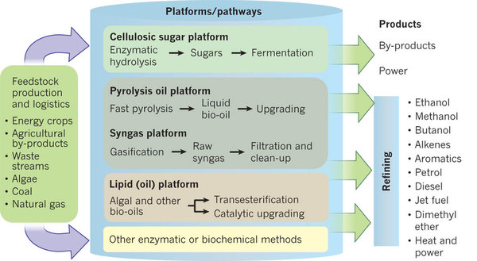
Various feedstocks are being explored, and the pathways for producing energy or fuel investigated.

Figure 4: Alternative fuel costs.
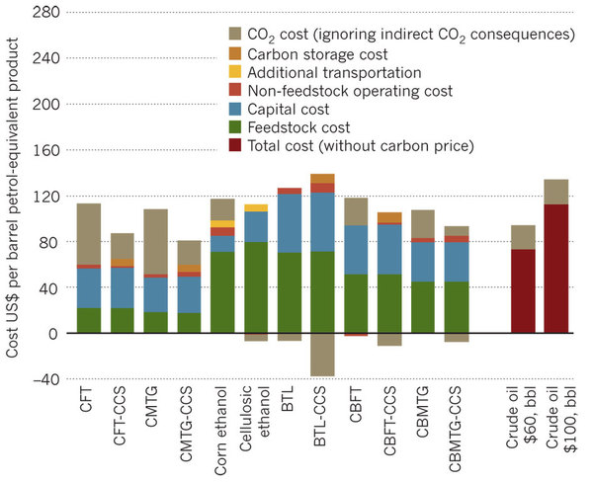
Estimated costs, achievable within 10–15 years, of alternative liquid fuels produced from coal, biomass, or coal and biomass with a CO₂ price of $50 per tonne and capital costs are 20% lower than the America's Energy Future panel's estimates. BTL, biomass-to-liquid fuel; CBFT, coal-and-biomass-to-liquid fuel, Fischer–Tropsch; CBMTG, coal-and-biomass-to-liquid fuel, methanol-to-gasoline; CCS, carbon capture and storage; CFT, coal-to-liquid fuel, Fischer–Tropsch; CMTG, coal-to-liquid fuel, methanol-to-gasoline..
The production of ethanol by domesticated yeast for fermentation is perhaps 4,000 years old. In this Insight, Paralta-Yahya et al.³³ review the application of metabolic engineering and synthetic biology to alter microbes for the production of advanced biofuels, and of precursors to drop-in substitutes for petrol, diesel and jet fuels. Static adjustment of transcription, translation and post-translational modifications does not allow engineered organisms to respond to changing bioreactor conditions and cellular changes. Remarkably, dynamic sensing and regulation of fatty-acid ethyl ester (FAEE) intermediates in Escherichia coli has been shown to increase FAEE yield by threefold, to reduce the cellular concentration of toxic intermediates and to significantly improve the genetic stability of producing strains.
Successful commercial-scale deployment of this class of technologies will depend on microbial productivity and robustness. The cost of microbial feedstock is also a major factor: production of advanced fuels from simple sugars and starches is further along in the development of these fuels, but it is held back by high feedstock prices. Lignocelluloses, including agricultural and wood-waste streams, are roughly an order of magnitude less costly, and are generally viewed as the end-goal feedstock. Much attention is now focussed on reducing the cost of converting lignocelluloses into forms that are more readily used by microbial organisms.
The net energy yield per hectare per year is a major factor in determining feedstock cost. The overall yield for biofuels varies widely: Brazilian sugarcane can produce as much as 800 gallons per acre-year, which is about twice as high as productivities based on North American maize. High-yield grasses or fast-growing trees that could be feedstocks for advanced biofuels have the potential to surpass sugarcane productivities by 1.3 times or more³⁴. Most lignocellulosic feedstocks have low-volume energy density: relative to fossil fuels they are 'light and fluffy'. To improve the economies of scale of biorefineries, especially thermochemical refineries, increasing the feedstock collection radius is desirable. Biofuels could become more competitive if a means of efficiently concentrating the biomass during the harvesting process (such as combining the reaping and pelleting the woody materials) could be developed. The same densification of the feedstock could also lead to the biofuel equivalent of grain elevators. Reducing 'first touch' costs are an integral part of efficient agricultural practice, and progress in this area would significantly lower the overall feedstock cost delivered to biorefineries.
In this Insight, Georgianna and Mayfield³⁵ discuss the use of algae to produce next generation biofuels. Algae can provide high fuel yields, especially if areal sunlight collection can be used to drive volumetric growth of algae. However, algal growth in closed systems requires very high capital investments relative to energy crops such as grasses or trees. In open-pond systems, water use is a major issue but may be partially ameliorated through the use of species that can grow in brackish or salt water.
Other approaches to bio-based fuel production include the manipulation of photosynthetic bacteria to produce biofuels, diverting high-energy Calvin-cycle intermediates upstream of glucose — for example energy-dense terpene (a biofuel precursor) production in trees or microbes — or developing alternatives to C₃ and C₄ carbon fixation.
Biological enzymes can synthesize carbon–carbon bonds with an unparalleled high specificity, but photosynthesis may not be the only approach to converting sunlight into hydrocarbon fuels³⁶. Several non-photosynthetic alternatives are under investigation that could potentially overcome many of the limitations of photosynthesis. To appreciate the potential of such approaches, the energy conversion process can be divided into three steps. First is to identify what reducing equivalents, other than solar photons captured through photosystems I and II, can be accepted by various microorganisms. Several organisms are known to be capable of growth on hydrogen sulphide, hydrogen, electrons, ammonia and reduced ions such as iron (II). Second is to investigate opportunities to fix CO₂ using pathways other than those used in C₃ or C₄ plants. Potential systems may include the reverse tricarboxylic-acid cycle (often called the reverse Krebs cycle), the Woods–Ljungdahl cycle used by acetogens, the hydroxypropionate–hydroxybutyrate cycle or newly designed biochemical pathways. The final step is to determine whether we can metabolically engineer direct carbon products into a molecule such as acetyl-CoA, which is a precursor for many energy-dense fuels. These three steps can be engineered into autotrophic organisms, an approach that is now being supported by a US DOE Advanced Research Projects Agency-Energy programme called Electrofuels³⁷.
Finally, researchers are investigating highly efficient non-biological energy-conversion approaches that generate fuel from sunlight by the oxidation of water into hydrogen and oxygen and reduction of CO₂ to fuel. The Joint Center for Artificial Photosynthesis, a US DOE funded Energy Innovation Research Center, was established to identify Earth-abundant, robust light absorbers with optimal bandgaps to harvest sunlight most effectively and efficiently, to accelerate the rate of catalyst discovery for solar energy-to-fuel conversion reactions and to provide system integration and scale-up so that laboratory experiments can quickly transition into prototypes for commercial development.

