M/5
- Explain Type I and Type II errors. Use an example if needed.

- Explain a one-tailed and two-tailed test. Use an example if
needed.

- Define the following terms in your own words.
  - Null hypothesis
  - P-value
  - Critical value
  - Statistically significant

- A homeowner is getting carpet installed. The installer is
charging her for 250 square feet. She thinks this is more than the actual space being carpeted. She asks a second installer to measure the space to confirm her doubt. Write the null hypothesis H_{o} and the alternative hypothesis H_{a}.

- . Drug A is the usual treatment for depression in graduate
students. Pfizer has a new drug, Drug B, that it thinks may be more effective. You have been hired to design the test program. As part of your project briefing, you decide to explain the logic of statistical testing to the people who are going to be working for you.
  - Write the research hypothesis and the null hypothesis.
  - Then construct a table like the one below, displaying the outcomes that would constitute Type I and Type II error.
  - Write a paragraph explaining which error would be more severe, and why.
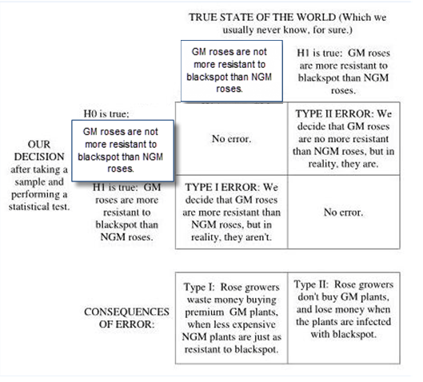

- . Cough-a-Lot children’s cough syrup is supposed to contain 6
ounces of medicine per bottle. However since the filling machine is not always precise, there can be variation from bottle to bottle. The amounts in the bottles are normally distributed with σ = 0.3 ounces. A quality assurance inspector measures 10 bottles and finds the following (in ounces):
5.95 | 6.10 | 5.98 | 6.01 | 6.25 | 5.85 | 5.91 | 6.05 | 5.88 | 5.91
Are the results enough evidence to conclude that the bottles are not filled adequately at the labeled amount of 6 ounces per bottle?
- State the hypothesis you will test.
- Calculate the test statistic.
- Find the P-value.
- What is the conclusion?

- Calculate a Z score when X = 20, μ = 17, and σ = 3.4.

- Using a standard normal probabilities table, interpret the
results for the Z score in Problem 7.

- Your babysitter claims that she is underpaid given the current
market. Her hourly wage is $12 per hour. You do some research and discover that the average wage in your area is $14 per hour with a standard deviation of 1.9. Calculate the Z score and use the table to find the standard normal probability. Based on your findings, should you give her a raise? Explain your reasoning as to why or why not.

- Tutor O-Rama claims that their services will raise student
SAT math scores at least 50 points. The average score on the math portion of the SAT is μ=350 and σ=35. The 100 students who completed the tutoring program had an average score of 385 points.
  - Is the students’ average score of 385 points significant at
the 5% and 1% levels to support Tutor O-Rama’s claim of at least a 50-point increase in the SAT score?

b. Is the Tutor O-Rama students’ average score of 385 points significantly different at the 5% and 1% levels from the average score of 350 points on the math portion of the SAT? What conclusion can you make, based on your results, about the effectiveness of Tutor O-Rama’s tutoring?

