Question #1:
The transformation formulas between Cartesian coordinates (x,y) and polar coordinates (r,θ) are as follows:
x = rcos(θ) y = rsin(θ)
r = sqrt(x² + y²) tan(θ) = y/x, where you have to determine which quadrant θ is in.
Every θ has a reference angle α as defined on pp.721-722, 747 in the book.
r is always positive. x and y can be either positive or negative.
For the following 5 cases, find the unknown quantities and draw the appropriate triangles, clearly labeling x, y, r, θ, and α. Round any numbers to 2 decimal places.
- If r = 5 and θ = 3π/4, find and label x, y, and α.
- If x = 3 and y = 4, find and label r, θ, and α.
- If x = 3 and y = -4, find and label r, θ, and α.
- If x = -3 and y = 4, find and label r, θ, and α.
- If x = -3 and y = -4, find and label r, θ, and α.

Question #2:
Verify the following trigonometric identity by using trigonometric identities on the right hand side of the equation. Hint: remember the math student’s pick up line. Hi, I’m sine squared. If you’re cosine squared, then we can be one for a date tonight!
sin²(x) = [ 1 – cos(2x) ]/2

Question #3:
Given the following triangle. Let hyp =12 and θ = 60 deg.
- What is β?
- What is x (adj)?
- What is y (opp)?
- What is the value of cos(β)?
- What is the value of the reference angle α that corresponds to θ?

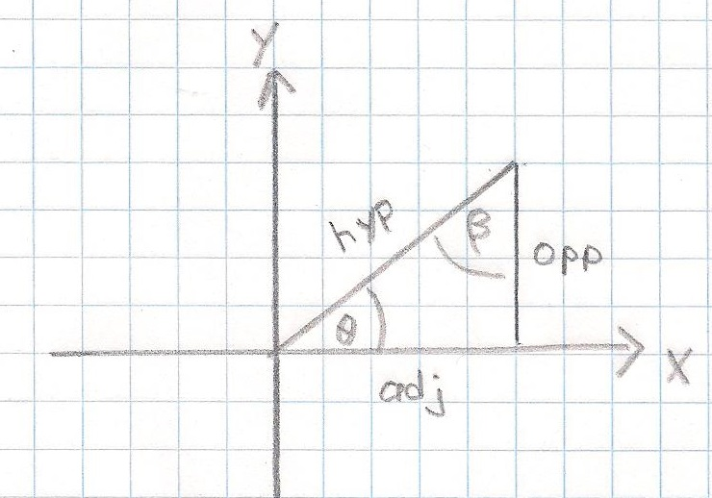

Question #4:
Solve: 2sin(2x) = 1
- What are the 2 values that (2x) can have?
- Draw the unit circle with the 2 triangles which correspond to your answers in (1). Clearly mark each of your (2x) angles in your figure.
- What are the 4 values that x can have?

Question #5:
Given the following triangle. Let hyp = 5 and θ = 210 deg.
- Draw the reference angle α.
- What is the value of α?
- Find β.
- Find x.
- Find y.
- What is the value of tan(θ)?

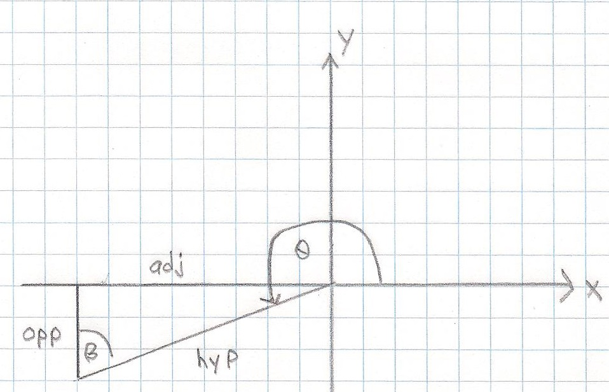

Question #6:
- Let sin(α) = cos(α+β). Expand cos(α+β) with the appropriate trigonometric angle addition formula and find a value for β.
- Let cos(α) = sin(α+β). Expand sin(α+β) with the appropriate trigonometric angle addition formula and find a value for β.

Question #7:
Find the value of z = tan(θ), where θ = arcos(4/5) or z = tan[ arcos(4/5)].
- Draw a circle and then the reference triangle (i.e. θ = α) with adj (or x) = 4, hyp (or r) = 5, and opp (or y) positive.
- What is the value of α?
- arccos is a double value function for [0,360). Draw the 2nd triangle (i.e. θ not equal to α) with opp (or y) negative.
- If θ = arcos(4/5), then what are the 2 values of θ?
- What are the 2 values of z?
Question #8:
Two sinusoidal functions of the same frequency, when added together or subtracted from each other, will produce a single sinusoidal function of that same frequency. The standard transformations using the angle addition formulas on p775 and p795 are:
y(t) = Acos(ωt) + Bsin(ωt)
= Dcos(φ)cos(ωt) + Dsin(φ)sin(ωt)
= Dcos(ωt – φ)
where D = sqrt(A² + B²) and tan(α) = B/A, A=Dcos(φ), B=Dsin(φ)
φ = α if A > 0
φ = α + π if A < 0
φ = π/2 if A = 0 and B > 0
φ = -π/2 if A = 0 and B < 0
Given: y(t) = 12cos(2πt/12 + π/4)
- What is the angular frequency ω? (be sure to state the units if t is time in sec)
- What is D?
- What is φ?
- What is A?
- What is B?
- Does D = sqrt(A² + B²)? (yes or no)
- What is α?
- What is the period T?
- What is the amplitude?
- y(t) is written in terms of radians. Re-write y(t) in terms of degrees.

