http://ramanujan.math.trinity.edu/wtrench/texts/TRENCH_LAGRANGE_MULTIPLIERS.PDF
the extrema subject to two constraints is on page 11 in the link above
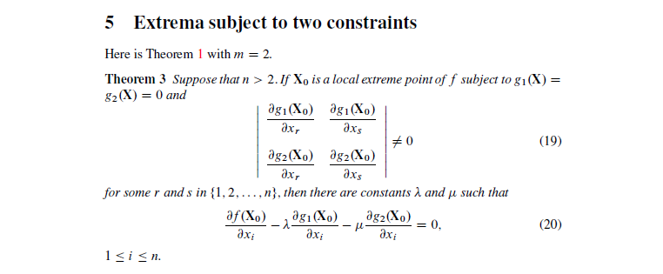
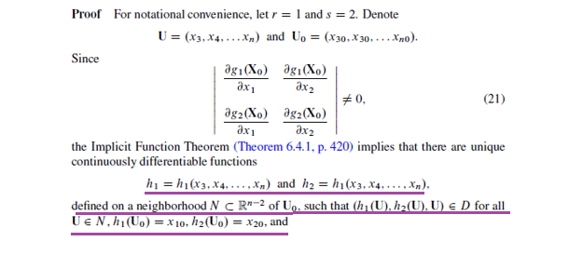
Can you point where all the mathematical notation underlined with violet above is in the implicit function since they use that proof. That is show where h₁ h₂, U, x₁₀, x₂₀, N and $R^{n-2}$ is in the general formulation of the implicit function theorem And why have they defined h₂=h₁?:

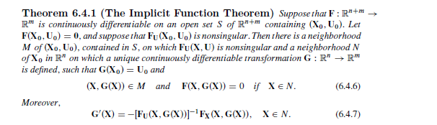

Search for the theorem in this link if you want to see more from the implicit function theorem. It is on page 420
http://ramanujan.math.trinity.edu/wtrench/texts/TRENCH_REAL_ANALYSIS.PDF

