Statistical Significance and Effect Size
a. Testing a Hypothesis: You previously assist me with a previous posting number 581870. Now this posted question is asking to rewrite your research question, null hypothesis, and alternative hypothesis from posting 581870. Make any needed improvements to create an appropriate hypothesis test that can be tested using the t or z test statistic to compare means. Is your test one-tailed or two-tailed?
b. Samples and Populations: Given your research question and hypothesis above, what would your population of interest be? Describe your population. To test your research hypothesis, describe the sample you might collect, including sampling method and size. Using your hypothesis test, sample size, and alpha as .05, use the appropriate Significance level T-table to determine the cut-off critical value(s) for your rejection region.
c. Considering Errors: Assume that you reject your null hypothesis. Describe the error that you would make in terms of your research question and conclusion, if you made a Type I error. Describe the error that you would make in terms of your research question and conclusion, if you made a Type II error. Which type of error is worse, and why?
d. Power and Effect Size: Suppose the effect size of your research study is very large. What does this tell you in your case? What can you say about your sample mean versus the population mean? How does the sample size and effect size alter the Power of a study?
Help and Explanations
For example a research question might be to investigate whether hospital ambulances arrive within their expected time frame of 15 minutes. Therefore, my null hypothesis would be that the response time is equal to 15 minutes. Note: the null ALWAYS includes the equality. My alternative or research hypothesis would be the opposite of my null, and would investigate whether ambulances do arrive in significantly less than or more than15 minutes.
Ho: mean Hospital Ambulances response times = 15 minutes
Ha: mean Hospital Ambulances response times ≠ 15 minutes
This is a two--tailed hypothesis test because my alternative “Ha” research hypothesis is looking at times that are not equal to 15 minutes.
Next, suppose I choose to run a single sample t-test with alpha equal to .05. Suppose my sample size is 15 ambulance times.
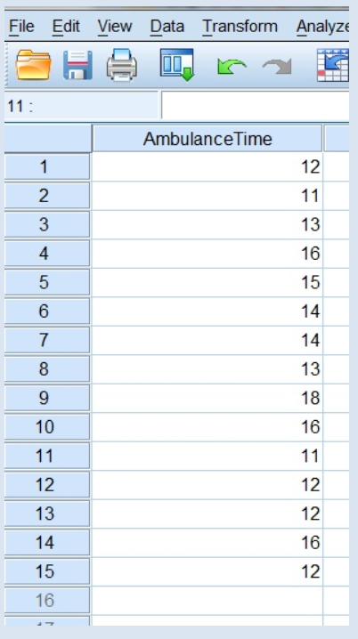
If I reject the null hypothesis, I can conclude that ambulances are taking either more or less than 15 minutes. Using the actual sample mean, I can then determine whether ambulances are taking longer than 15 min or less than 15 minutes. This result might lead me to feel confident about the response times of ambulances, assuming that the sample mean is less than 15 minutes.
If I reject the null hypothesis, this means that the p-value (called Sig.(2-tailed) in SPSS) was less that my alpha value of .05. This also means that my t-test result was inside of a rejection region.
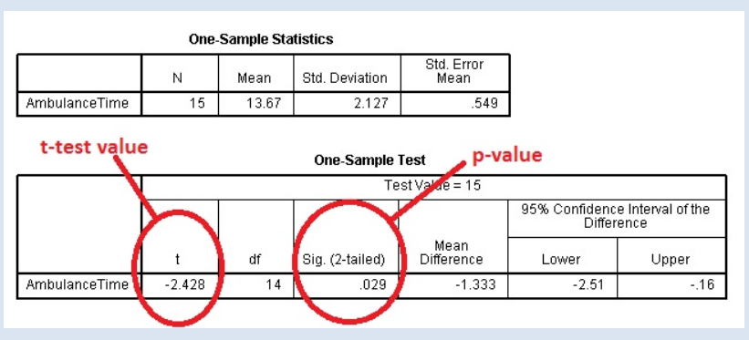
Here, you can see that my sample mean is 13.67. We can also see that the t-test value is -2.428 and the p-value (called Sig (2-tailed)) is .029.
My t-test value is in the rejection region.
How do I know where the rejection region is?
I have to look it up on a t-table (found in the textbook Appendix).
To look up the cut-off value for the rejection regions of a two tailed t –test, I need a few things.
1) I need an alpha value, which is commonly .05.
2) I need the degrees of freedom df, which is 14 in this case. The degrees of freedom can be calculated by hand by finding the sample size n – 1.
3) I need a t-table which is in the Appendix of your book and in Doc Sharing.
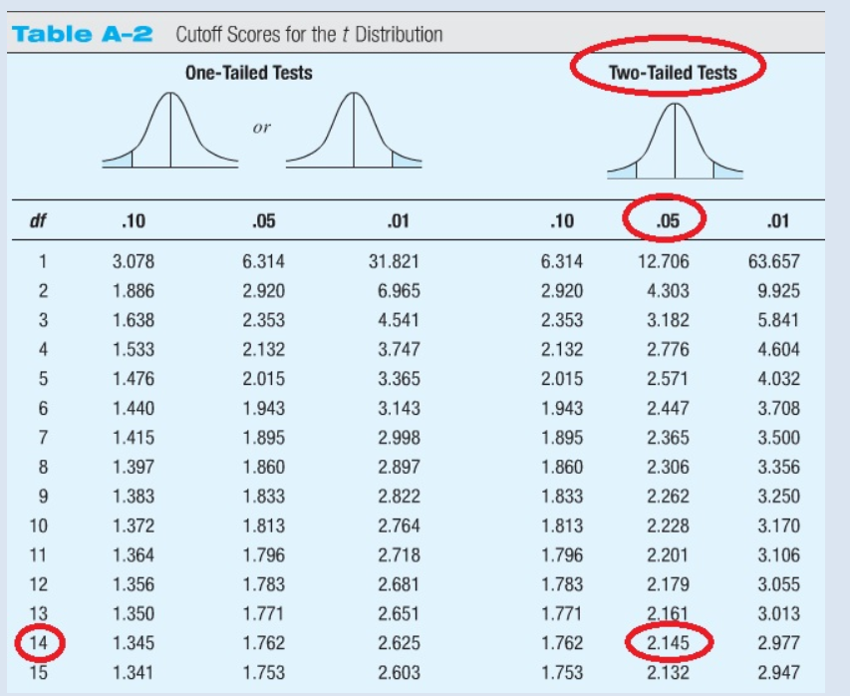
Now, using the t-table and alpha is .05, and df is 14, I find that the cutoff value is 2.145 and -2.145. Because my t-test value is in the rejection region, I can reject Ho.
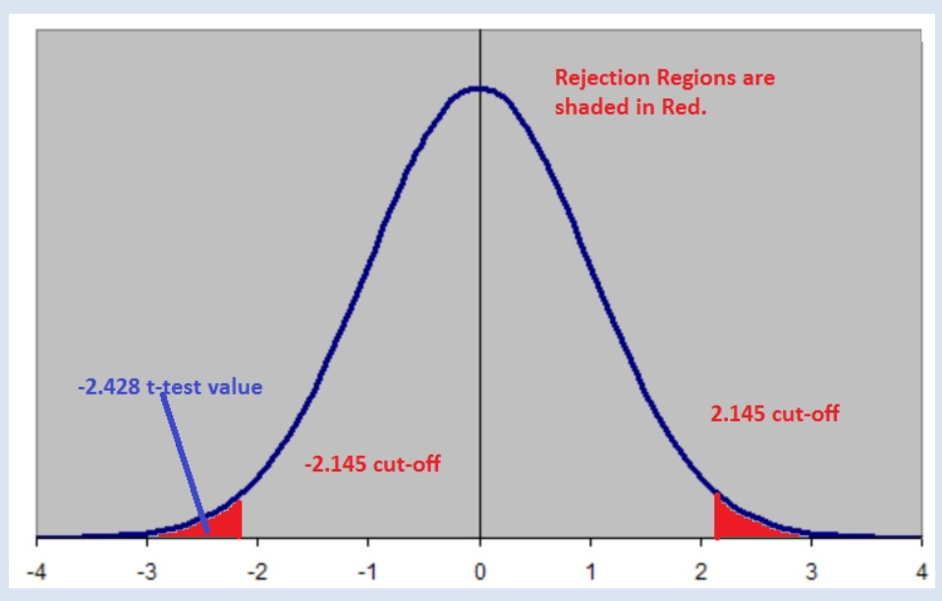
In addition, I can also use the p-value (Sig. 2-tailed in SPSS) to make this same determination.
My p-value here is .029. Because .029 < alpha of .05, I can reject the null hypothesis Ho. The p-value is calculated from the t-test value, so both results will always lead to the same conclusion. You can use either to make your decision!
My population of interest here is all Hospital Ambulance response times that have ever occurred. My sample of this population is a sample of the response times for 15 randomly sampled Hospital Ambulances. I will collect all 15 response times and calculate the sample mean. In my test, I will be looking at whether my sample mean is significantly different from the assumed population mean of 15 minutes.
If I reject the null, I can conclude that ambulances are taking either less than 15 minutes or more than 15 minutes on average. In this case, as shown above, Ho is rejected. There is a significant difference between my sample mean and the population mean. In my case, my mean time is lower as shown in the SPSS output above.
In a Type I Error, I would have rejected the null when it is in fact it was actually correct. In my case, this would mean that my sample has incorrectly implied that Hospital Ambulances are taking less than 15 minutes when in fact they are not. This can happen if my sample was improperly collected, skewed, too small, not random, or perhaps other reasons.
In a Type II Error, I do not reject the null, but I should have. In other words, I conclude that Ambulance response times are 15 minutes, but in fact they are really taking less time. Again, this error can occur from a sample that is too small or faulty in some way.
In my case, a Type I error is worse to make! Can you think of why?
Suppose my sample mean of ambulance response times is 7 minutes and the population mean is 15 minutes. This large difference will create a large effect size for my study because effect size is measured as the difference between my two means divided by the standard deviation of the population.
A large effect size will mean that the results of my study are very statistically significant. The Power of my study is the probability that it will produce a significant result, assuming my research hypothesis is true. There are many factors that can affect Power, such as my sample size, the size of alpha, and the effect size. In my case, my sample size is not large (< 30) and therefore, my effect may be smaller. I also expect the Power of my study to be less that it would be if I have a much larger sample.

