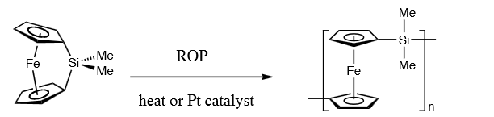
[1]Ferrocenophane
2 mechanisms
1. Pt- catalyzed ROP
2. Thermal ROP

