Background Information

Taxonomy, simply stated, is the practice and science of classifying organisms arranged into a hierarchical structure. Each level of the classification system places species into groups based on their shared common features while separating groups of species because of their differences. For instance, species appearing more closely related are grouped into the same genus. In this lab you will be observing 10 different species with respect to their phylum. In sections 2-9 you will document the features common to the corresponding phylum. In column 10, you will identify the organism.
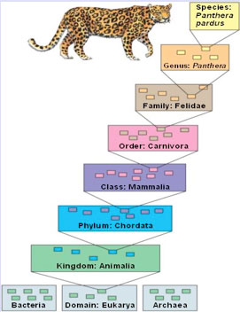

Phylum\Division

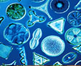 Chrysophyta: Unicellular, primary producers
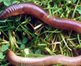 Annelida: Segmented body
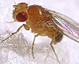 Arthropoda: External skeleton and segmented body
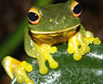 Amphibia: Can obtain oxygen from aquatic and terrestrial biomes
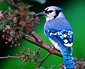 Aves: Able to fly; covered with feathers
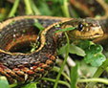 Reptilians: Covered with scales
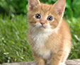 Mammalia: Nurture their young with milk
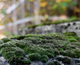 Bryophyta: Nonvascular plants
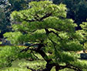 Gymnosperm: Have needles and seeds but no flowers
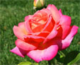 Angiosperm; Have flowers

Nutrition

Autotrophic
Angiosperm
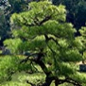Gymnosperm
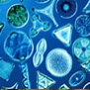Chrysophyta
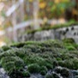Bryophyta
Heterotrophic: Earthworms eat their way through dirt, so they are detritivores.
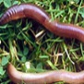Annelida
Heterotrophic: Some are vegetarian, some are carnivorous, and some are decomposers.
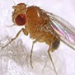Arthropoda
Heterotrophic: These are usually vegetarian as tadpoles and carnivores as adults.
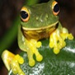Amphibia

Heterotrophic
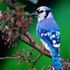Aves
Mammalia
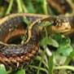Reptilians

Circulatory System (Transport)
Diffusion only
Chrysophyta
Closed with 5 aortic arches (hearts)
Annelida
Open circulatory system with a heart pumping hemolymph
Arthropoda
Closed with 3-chambered heart
Amphibia
Closed with 4-chambered heart
Mammalia
Aves
Reptilians
Diffusion through cell walls and cell membranes
Bryophyta
Xylem and phloem
Angiosperm
Gymnosperm

Respiratory System

Diffusion only
Chrysophyta
Diffusion through skin
Annelida
Diffusion through tracheal tubes
Arthropoda
Diffusion through gills as a tadpole and through lungs and skin (especially) as adults
Amphibia

Diffusion through the lungs
Aves
Reptilians
Mammalia
Diffusion through cell membranes
Bryophyta
Diffusion through stomata
Gymnosperm
Angiosperm

Reproductive System
Asexual
Chrysophyta
Hermaphrodites: One body has both sexes Sexual: Has special organ called clitellum that moves from the front of the worm to the rear and then falls off, containing the eggs
Annelida
Sexual: Mostly internal fertilization
Arthropoda
Sexual: Mostly external fertilization; must be in water or very moist area
Amphibia
Sexual: Eggs; internal
Aves
Reptilians
Sexual: Placental, in-uterus development (internal)
Mammalia
Sexual: Alternation of generations. Must be in a moist area for the sperm to swim to the egg
Bryophyta
Sexual: Alternation of generations. Pollen is the male sex cell
Angiosperm
Gymnosperm

Excretory System

Diffusion
Chrysophyta
Nephridia in each segment; solid waste exits through the anus
Annelida
Malpighian tubules
Arthropoda

Kidneys, intestines, anus
Aves
Reptilians
Mammalia
Amphibia

None
Angiosperm
Bryophyta
Gymnosperm

Growth and Development
Start as small cells; grow bigger until division
Chrysophyta
Start out as fertilized eggs, hatch into little worms that continue to grow, and then mature sexually into adults
Annelida
Complete (egg, larvae, pupae, adult) or incomplete (egg, nymph, adult) metamorphosis
Arthropoda
Metamorphosis: Egg, tadpole, adult
Amphibia

Develop in egg
Aves
Reptilians
Develop in-uterus
Mammalia
Spores, not seeds
Bryophyta
Naked seeds in cones
Gymnosperm
Seeds protected in pods, shells, fruit, and so forth
Angiosperm

Regulation

The nucleus directs protein synthesis. Euglena have eye spots that can detect light
Chrysophyta
Tiny anterior brain, ganglia, and the nerve cord runs the length of the body
Annelida
Tiny anterior brain, nerve cord, ganglia, and extremely well-developed sensory organs
Arthropoda
Brain, nervous system, good reflexes
Amphibia
Nervous and endocrine systems
Reptilians
Aves
Big brain; well-developed nervous system and endocrine system
Mammalia
None
Bryophyta
Hormones in apical bud, root, and stem
Gymnosperm
Hormones in apical bud, root, stem, and leaves
Angiosperm

Sample Organism
Phytoplankton
Chrysophyta
Earthworm
Annelida
Fruit fly
Arthropoda
Frog
Amphibia
Bird
Aves
Snake
Reptilians
Cat
Mammalia
Moss
Bryophyta
Pine tree
Gymnosperm
Rose
Angiosperm

Reference
Audesirk, T., Audesirk, G., & Byers, B. E. (2010). Biology: Life on earth with physiology (9th ed.). Upper Saddle River, NJ: Prentice Hall.

