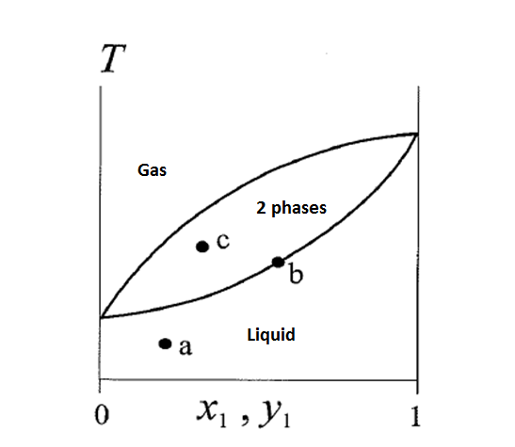
In the diagam above we assume constant pressure and we have number of degrees of freedom
F=C-P+1

But in the two phases part we add another one and get
F=C-P+2
In my book they say the reason for this is that we also can change the composition of the phases as well as changing temperature

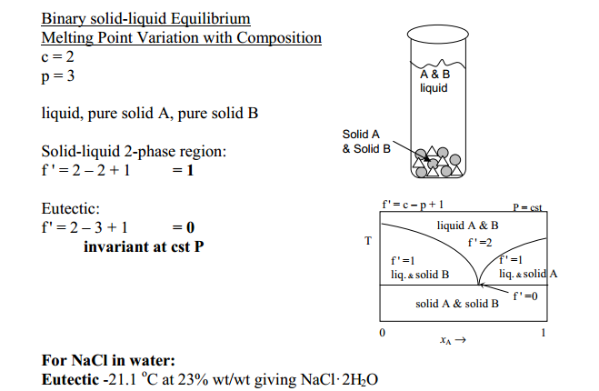

Why do they add a degree of freedom for two phase liquid in the grey part but they don’t do that in for equilibrium between solid and liquid in f’=1 in the orange part when there is a two phase equilibrium there as well? I want to have a general explanation for this from the degrees of freedom derivation by using the number of chemical potential equilibriums and number of composition variables that they base the degrees of freedom derivation on. The derivation for the degrees of freedom are attached here:
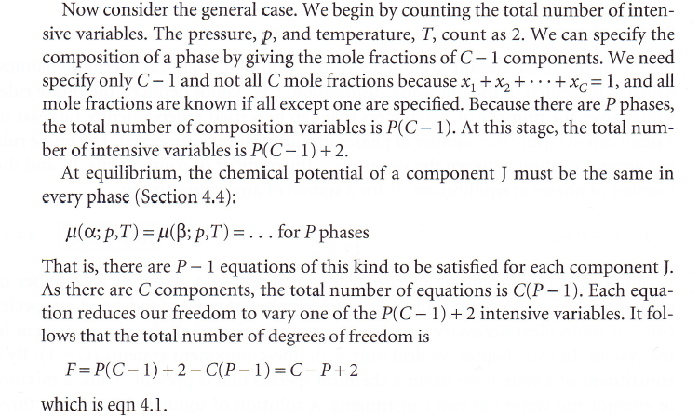
The last part is taken from Atkins physical chemistry

