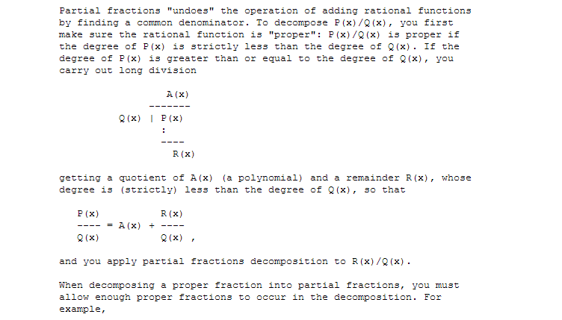
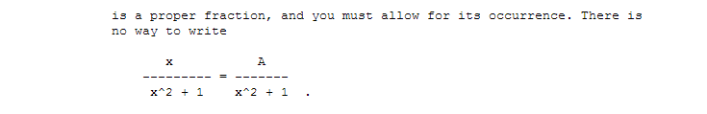
I get that you can have an polynomial with a left over as here and that it then is irreducible.
But is it possible to show a direct mathematical relation to a partial fraction expansion for why you need Ax+B in the numerator for this. For example this expansion:
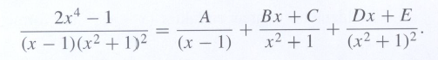
$$2x^{4}-1=A{\left(x^{2}+1\right)}^{2}+\left(Bx+C\right)\left(x-1\right)\left(x^{2}+1\right)+\left(Dx+E\right)\left(x-1\right)$$
Where the irreducible factor is $x^{2}+1$?
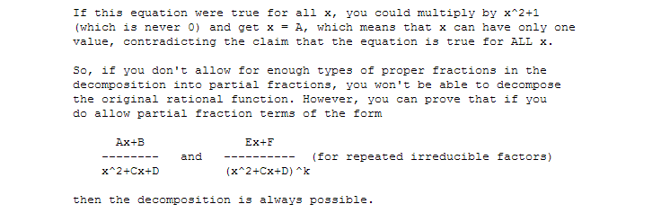

And do you have a proof for the last part he says there is a proof for here:
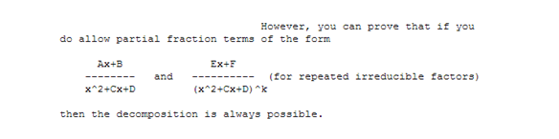

http://mathforum.org/library/drmath/view/51687.html

