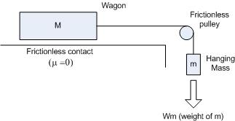

The mass of the wagon (M) and the hanging mass (m) are in kilograms. The total mass of the system is M_{t}, the sum of M and m. The acceleration of gravity (g) is 9.8 m/s² . The acceleration of the system (a) varies, depending upon the experimental values of M, m, and µ. In the situation shown above (μ = 0), the only force acting on the system is the weight of the hanging mass, W_{m}.
Fill in the following table, using the value of a obtained from the simulation. Record and calculate data to the nearest three decimal places. The masses in the table are in kg, but the input data are in grams, so make the necessary conversions. The first row has been completed for you.
M m a W_{m} M_{t} (M_{t})a
.100 .01 .892 .098 .11 .098
.100 .03
.100 .05
.100 .07
.100 .10
Discuss your results. How do they demonstrate Newton's Second Law (F = ma)?

