Organizational Management: CBP as a Bureaucracy

The organization that I work for is one of the primary agencies of the US federal Government. Its main trust is to regulate and facilitate international trade, collect import duties, as well as enforce U.S. regulations, including trade, customs and immigration. It is a massive agency under the Department of Homeland Security (DHS) umbrella and since it is federal, because of its sheer responsibility it is the largest law enforcement agency in the US. At the moment it has over 43,600 sworn-in agents and officers out of a total employee number of 58,000. The specializations of its employee-base are diverse as outside of its agents and officers it has agriculture specialists, aircraft pilots, trade specialists, mission support staff (for both domestic and international missions) and canine enforcement officers and their specialist canine units. The sheer size of the organization demands a specialist bureaucratic form of administration and leadership as the scope of the roles of CBP's officers and agents are not only vast but also of the essence to protect America's borders and ensure that its laws are enforced. For instance, it has units whose aims are to stem criminal activities from white collar money laundering schemes to the dangerous and violent world brought on by illegal drugs trafficking, human trafficking and trafficking and trade of child pornography. The organization therefore is rank-based comparable to the rank-based system utilized in the Federal Bureau of Investigation (FBI) for example. Individuals make up small units where power and authority is according to rank and role and each small unit make up a bigger agency assigned according to geographic and specialist roles. Central power comes from the Office of the CBP Commissioner who is assisted by his Deputy. Leaders of his varied agencies and support offices report directly to him while the Chief of Staff from the executive branch of government as well as the Office of Chief Counsel also have a direct say in the management of his office. There are 14 different 'main offices' that directly report to the Commissioner too and each of these offices are specialist units that have their own particular directive each headed by either a Chief or an Assistant Commissioner (for full organizational description, see attached 2011 Chart below). It is thus no surprise that CBP follows the normative path of Bureaucratic management which is described as (Vector Study, 2011) "a formal system of organisation based on clearly defined hierarchical levels and roles in order to maintain efficiency and effectiveness."

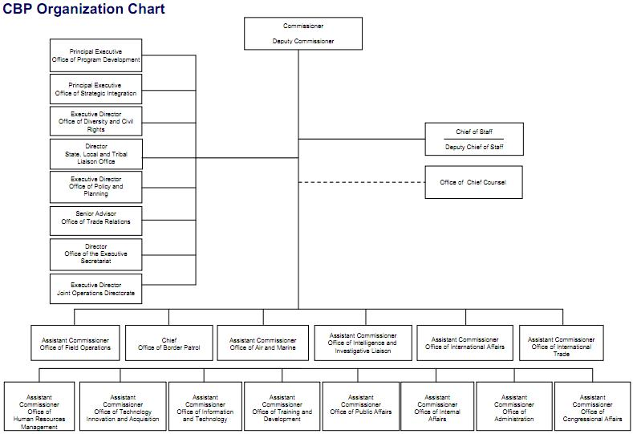

To best understand normative bureaucracy, it would be advisable to look at the ideas of German thinker Max Weber. As a sociologist he observed that government management entails a different form of organizational approach based on hierarchy and role. He observed that there are 3 different kinds of authorities in society and they are as follows: traditional - comes from tradition, as in the authority of the patriarch over a family, charismatic - comes from the establishment of respect and influence as in the authority of political or religious leader over the people that have come to follow or to listen to him and lastly, the rational-legal wherein the authority comes from the position that one holds in an organization. The organization, once accepted and established as essential by the community and the larger society, it derives power and authority from it as citizens and members of that particular social group (i.e. the American nation) become bound to the rules and policies of that particular organization as one of the main structures that allow for their particular way of life to happen and be maintained. It is the rules and the bureaucratic organization that allows for the continuity of CBP. Its leaders and employees might change as they move forward in the organization, change offices or leave entirely.

Control and authority is provided by the office, rank and responsibility one holds. Leadership therefore is all about democratic control. Granted, offices are prone to politics whereby ally themselves with like-minded members to move forward a particular agenda or goal. Granted, individual members will have their own sense of ethics, influenced by their personal experience and socialization as well as ethnicity. But when it comes to behaviour within the organization, bureaucratic leadership demands sticking to established behavioural policies. Also, becoming a member of CBP means taking into account certain organizational identities - people ascribe to it and behave accordingly. Members are motivated and inspired not only by their own team leaders but by their managers and supervisors and ultimately by the Commissioner. Time and again they are reminded of their role and the impact of the tasks they must perform. While inspiration from speeches, conventions and memorandums are not assured (being that there is a distinct lack of direct communication between because the organization is formal, thus communication requires going through proper channels), each member sign on an employment contract whereby they agree to perform their tasks and behave in a certain manner or be held accountable making all directives from top down essentially 'the rule of law'.

Leadership Evaluation

How effective is the leadership and management style of the CBP? The CBP exists due to the mandate of the DHS. It is a formal organization whose structure and shaped has been decided upon by the government to fulfil a particular task as we have established earlier. The roles in the organization and the tasks of its varied branches and its people are defined prior to the event whereby the government started hiring and searching for the right candidate to perform them. Power and authority flows from the top-down. All of its members answer to their immediate superior and their immediate superior to someone else much higher. It is a pyramid of power. Leadership evaluation must therefore first and foremost be assessed from the ability of the leaders of the organization to perform the tasks of office. As each office and role have specific tasks to perform, shortcomings in performing such tasks are points against their ability as leaders and managers. It is important to note that in a bureaucracy, leaders are above all people managers. How do you ensure that the people working under you perform their tasks as effectively as possible? This means managing their roles as well as ensuring that their personalities do not clash. It is not a place for mollycoddling but a site for maturity. Even if members dislike each other's opinion, as power emanates from top-down, they will have no other choice but to work together to perform a particular task - the definition, in this case, of professional performance.

In our particular organization, leadership styles vary. Leadership styles can increase the effectiveness of leader in different environments and situations. Leaders can be more effective if they can adapt leadership styles to situations and followers. Leaders must possess the ability to identify indications of different environment and situations to vary their behavior. I hold a particular position in my office in the CBP. I am a Supervisory Customs and Border Protection Officer which means that I am a team leader and that my role has an important impact in my area of responsibility. I have decided, for this exercise to reflect on my own leadership. In my role, I try to be as honest, forward-looking, inspiring, fair-minded, broad-minded, and straightforward. It is my goal to be as sincere and fair to my team members and to the people I serve. When performing my role in the field, I have to be able to take charge but also I have to ensure that I am sensitive to people's feelings, values, and interests which mean that I have to recognize the importance and impact of cultural diversity. This means deciding as soundly as possible on all occasions. At a supervisory level, we always have to self-assess and regular self-assessment exercises reveal that I emphasize on proper behavior at work and encourage the development of abilities and skills while nurturing good working relationships with the people I work with. I am a Finance Major graduate and my approach to public administration is influenced by my studies of finance management. This means looking into economies of scale - I look at each task and each unit by measures of resources - what is the task, what are the available resources, how best can they be achieved whereby resources, monetary or humanitarian, are maximized? Also, I am quite aware of politics. In my organization, politics plays a vital role from upper management to the smallest units. As a supervisor, I must always be aware of office politics as this has an effect in the resources I can access for my team and our tasks. This does not mean taking sides however, it only means understanding office and department politics. This also affects the way mobility works as certain managers, supervisors and administrations have specific ways of assessing and valuing recruits and team members as each have their own interpretation of certain roles. I must therefore be aware of this so I can ensure that politics do not get in the way of the performance of my role and that of my team members. I am aware that politics can be harmful and that egos and interpretations are very subjective thus I must always approach such issues with diplomacy. Politics is essential as it is a way of negotiating power so awareness of it allows me to negotiate the best possible solutions for my office, for myself and for my team.

SWOT: Strategies for Improvement

What is a SWOT analysis? It is a strategic planning tool utilized by organizations and businesses to assess the Strengths, Weaknesses/Limitations, Opportunities, and Threats that confront an organization or an individual undertaking/project. It basically involves identifying the following elements (table from Business balls, 2012):

Strengths and Weaknesses | the internal environment - the situation inside the company or organization | for example, factors relating to products, pricing, costs, profitability, performance, quality, people, skills, adaptability, brands, services, reputation, processes, infrastructure, etc. | factors tend to be in the present
Opportunities and Threats | the external environment - the situation outside the company or organization | for example, factors relating to markets, sectors, audience, fashion, seasonality, trends, competition, economics, politics, society, culture, technology, environmental, media, law, etc. | factors tend to be in the future

So far, my SWOT analysis has shown brought to attention the following concerns. Opportunities or problems are always present in Public Entities. The most important thing to do is to recognize the problem. Once you have the problem, it must be analyzed. What are the variables involved? Do I need a financial solution or do I need more complex results? Are there moral/ethical sides to the problem? I have a financial background and I tended to be inclined to use a Cost-Benefit technique. As I have gained experience in the management field, I have adapted to using different techniques of decision making. The opportunities in my role are not always obvious - they can however be observed once problems are identified as resolutions bring about changes and development.

Staff is always an issue when you have to deal with providing a service to the public. The paying public wants to be served as soon as possible. As a Supervisory Customs and Border Protection Officer, I face budgetary constraints. What staff level should I utilize to inspect travelers? I use the Cost-Benefit technique to solve this issue. I break down my costs and benefits into categories. My real benefit is the traveling consumer’s satisfaction on the time spent in the inspection area. The real cost is the money spent on wages to process the travelers promptly. The indirect benefit is that travelers would prefer the Houston Airport as their port of entry. The indirect cost would be that other very important functions in Immigration or Customs would suffer from lack of funds. I see how cost effective is the utilization of funds in one area or another and then I make the final decision on utilization of resources.

Immigration law is very extensive and it contains grey areas. Decisions must be made in which discretion must be used. There are financial costs but there are also moral/ethical issues involved. I use the multi-objective model technique to solve these situations. I collect all the obtainable facts and then I evaluate the most relevant conditions. I give a level of importance to every relevant criterion. To make the final decision, I consider each alternative on how it achieves the desired results.

We often use Group Decision-Making techniques at work. We make decisions that may be challenged in immigration courts. We gather a wider angle of any problem and its causes and possible effects. These group decisions help us analyze the sometimes grey areas in immigration law. Our diversity can help us to approach the very diverse traveling population with psychological, compromising, and inclusive solutions.

I will consider what decision technique to use once I have identified the problem. I will consider the variables involved and how complex the problem is. I will not stop using the cost-benefit or the multi-objective techniques which I find very useful. I will start utilizing other ones. Through the reading I perceived that I can positively incorporate the operations management and the Group-Decision making techniques to my decision making strategies.

Conclusion

My role as a Supervisory Customs and Border Protection Officer is not always easy. Not only do I have to perform my own tasks, I have also to manage a team of people whereby our team has a particular directive and set of tasks and responsibilities to fulfill. SWOT has shown that strategies must focus n problem solving as our office must always deal with a host of issues internally and externally. It is in finding potential solutions that opportunities present themselves. By providing solutions, the team can move forward and achieve the task at hand which also means moving individual members forward in the bureaucratic ladder. An essential issue is access to resources. Another one is safety not only of the public but of team members. This could be a potential weakness. But opportunities lie in training and acquisition of new skills, abilities as well as utilization of new technologies. I am always aware that there are new ideas out there as well as new technologies and approaches that can be utilized. I know that not all will fit what my office and my team members need and also, I am constrained by budgetary and policy concerns. But where I can acquire new training for myself and my team, as well as access new technologies, I make sure that I request and receive it. This requires working the bureaucracy and playing politics. I see that politics at times can be a hindrance in smooth operations and even from our end, requests for training and equipment can be a little slow due to red tape. But patience is an important part of my role as well as the ability to look at all possible source of resources and support which can be done by playing office politics. This is an area where I think improvement is necessary.

References:
(Web)
CBP (2012). About CBP. CBP, a division of the Department of Homeland Security. URL: http://www.cbp.gov/xp/cgov/about/
Staff (2012). SWOT analysis. Business Balls. URL: http://www.businessballs.com/swotanalysisfreetemplate.htm
Staff (2011). Bureaucratic Management. Vector Study. URL: http://www.vectorstudy.com/management_schools/bureaucratic_management.htm
(Print)
Daft, J. & Murphy, H. W. (2010).Organization theory and design. Cengage Learning EMEA.
Jacobs, T. O., & Jaques, E. (1987). Leadership in Complex Systems, in Praeger (Ed.), Human Productivity Enhancement (Vol. 2, pp. 7–65). New York.
Roethlisberger, F.J., & Dickson, J.W. (1943). Management and the Worker. Cambridge, MA: Harvard University Press.
Weber, M. (author), Parsons, T. (ed) (1997). The Theory of Social and Economic Organization (original 1915). The Free Press.

