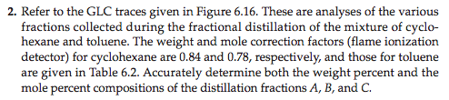
Toluene: 1.01 and 0.86, respectively from Table 6.2
